Diagnostic Testing
Your eyesight is priceless, and we are here to protect it!
OCT Wellness Exam:
Vision-threatening diseases often have no outward signs or symptoms in the early stages, so our practice has begun using state-of-the-art technology to assess the health of your eyes. The OCT Wellness Exam is a quick, non-invasive scan that allows our doctors to see beneath the surface of your retina. This unique technology can help our doctors detect vision-threatening diseases in their early stages, when they are most treatable.
If you choose to, our technician will perform the OCT Wellness Exam which your doctor will review with you. The $20 charge is typically not covered by your insurance if there are no medical findings, so this will be added into the cost of your visit today. Any questions you have about OCT Wellness Exam and the results of the test can be discussed with the doctor during your examination.
Initial: ________________________
OCT Wellness Exam examples:
Healthy Retina
Unhealthy Retina
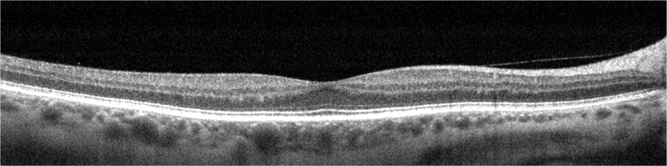
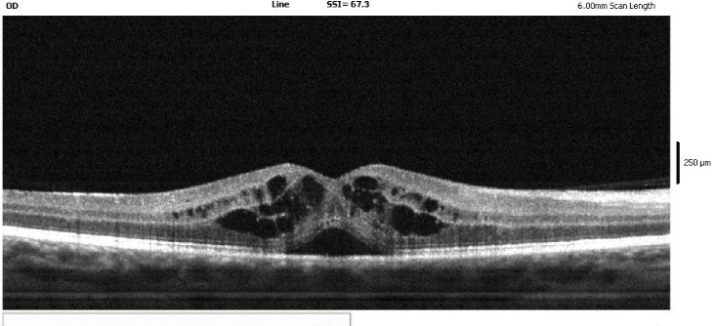
Optomap Fundus Photo:
Another way for our doctors to better assess the health of your eyes is through our state-of-the-art fundus camera, the Optomap. The Optomap provides our doctors a 200° view of the back of the eye to assess the health of your retina, optic nerve, veins, and much more! The Optomap is also a non-invasive procedure in which our technicians would take three photos of each eye. These photos will be reviewed by the doctor and to you as well. The photos will remain on your record so that we can always compare previous findings to current findings. The $35 charge is typically not covered by your insurance if there are no medical findings, so this will be added into the cost of today’s visit.
Initial: ________________________
OCT + Optomap Combination:
Includes both the OCT Wellness Exam AND the Optomap photo at a discount for a $50 charge.
Initial: ________________________
Ocular Dilation:
By choosing this option, you are opting out of the Optomap Fundus Photo and approving the use of ocular dilation to be performed IF the doctor deems necessary.
Initial: ________________________

PATIENT INFORMATION FORM
Name (Last, First, MI): ______________________________________________________________________
Address: _______________________________ Apt # _____ City_____________ State _____ Zip ________
Home Phone: ___________________ Work Phone: __________________ Cell Phone: ________________
E-Mail Address: __________________________________________________________________________
Date of Birth: ________________ Age: _____ Sex: M F SS#: ______________________
Employer (or School): __________________________ Occupation (or Grade): _______________________
RELEASE OF INFORMATION
“I consent the release of my information to the following persons.”
Name: _____________________________________________ Relationship: ______________________
Phone Number: ____________________________ E-Mail: ____________________________________
ACKNOWLEDGEMENT OF HIPAA PRIVACY PRACTICES
“I acknowledge that I have been informed of the Patient Privacy Policy of this office in accordance with the Federal Health Insurance Portability and Accountability Act (HIPAA).”
Signature: ________________________________________________ Date: _____________________
Guardian, if under 18 years of age: ________________________________ Date: _________________
CONSENT OF TREATMENT
“I understand that my signature denotes my understanding of the informed consent.”
Signature: ________________________________________________ Date: _____________________
Guardian, if under 18 years of age: ________________________________ Date: _________________
INSURANCE INFORMATION
Primary Holder’s Name: __________________________________________ DOB: _______________
SS #/ID #: __________________________ Relationship: Self / Spouse / Child – Parent / Other
*For photo copies of your insurance cards, please e-mail them to: insurance@taeyecare.com
Release of Information to Insurance Policies
“I authorize the release of information regarding my treatment/condition to obtain payment for professional services. I authorize Ta Eye Associates, PLLC to use “SIGNATURE ON FILE” in actual signature on insurance claim forms.”
Signature: ________________________________________________ Date: _____________________
Guardian, if under 18 years of age: ________________________________ Date: _________________
Assignment of Benefits
“I authorize payment of medical benefits to Ta Eye Associates, PLLC for services rendered. I understand that I am financially responsible for all charges not paid by my insurance plan.”
Signature: ________________________________________________ Date: _____________________
Guardian, if under 18 years of age: ________________________________ Date: _________________

